logoNovitech.gif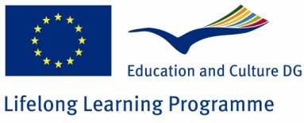

Valorization 1

Extension of training, Inclusion of transfered curriculum to training pans to to NTP and IQC

|  |  |
| --- | --- |
| Programme: | **Lifelong learning programme** |
| Sub-programme: | **Leonardo da Vinci** |
| Action: | **Transfer of innovation** |
| Project title: | **Innovation Suite training curriculum for SME managers** |
| Activity: | **Valorization 1** |
| Applicant name: | **Novitech Partner s.r.o.** |
| Project ID- LLP LINK: | **2010-1-SK1-LEO05-01566** |

Contents

1. Introduction 4

2. Outcomes of the project 5

2.1 Tangible outcomes of the project 5

2.2 The intangible outcome of the project 5

3. Impact of the project 5

4. Role of the project partners 6

4.1 Project coordinator (P0) - Novitech Partner s.r.o. 6

4.2 Project partner (P1) - CREAX NV 6

4.3 Project partner (P2) - IQ Consulting Kft. 7

5. Necessity of the project 8

5.1 INNOVATION PERFORMANCE (2009 SUMMARY INNOVATION INDEX) 9

5.2 REGIONAL INNOVATION SCOREBOARD 10

5.3 Innovation indicators for SMEs in Slovakia nad Hungary 11

6. Aims and Objectives 15

7. Type of Transfer 16

7.1 Sectoral transfer 16

7.1.1 Content description 16

7.1.2 Method of transfer 16

7.2 Geographical transfer 17

8. Base of the innovative content 18

9. Quality of the consortium 19

10. European added value 21

11. Methodology and workplans 22

11.1 The work plan 22

11.2 Deliverables of the project 24

11.3 Support actions 25

11.4 Translation and training activities time table 25

11. 5 Activity: Activity description 25

12. Dissemination and exploitation of results 26

12.1 Dissemination during the project 26

12.2 Dissemination after project completion 27

13. Quality management plan 29

14. Expected impact 30

14.1 Indicators for impact on target groups and/or sectors 30

14.2 Indicators for impact on geographical areas 30

15. Project budget 32

16. Conclusion 34

# 1. Introduction

The reason of the project is derived from the findings of the European Innobarometer 2009 report: "training with the goal of supporting innovation was the second-most widespread investment that EU enterprises reported: 50% had such expenditure and 63% of these enterprises increased the amount spent when comparing 2008 to 2006. 57% are involved in innovation but do not gain significant revenues from its products". In other words: they spent more and gained less.

The situation is even more serious in the SME category where in EU average 10% does not innovate at all. And in the catching up countries of Slovakia and in Hungary this average is around 30%. The causes of this situation in the Hungary and Slovakia regions are several:

1- The lack of practical and relevant innovation learning resources with specific focus to business environment of SMEs.

2- Fragmented and general learning resources and case studies of networks, scientific journals, etc. cannot be applied directly to the daily business of an SME

3- Inconsistent innovation and creativity trainings and assessment methods.

The above findings are the summary outcomes of Regional Innovation Forums organized by Novitech Partner in 2007 and 2009.

The immediate objective of the project is reduce the above innovation learning gap in the SME Regions of Hungary and Slovakia by transferring a proven training curriculum.

The source of transfer is the Innovation Suite developed by CREAX (P1) already successfully delivering these training to SMEs in BeneLux. Primary beneficiaries are two training organizations: Novitech Partner(P0) and IQC(P2). Partners P0 and P2 will deliver InSuite learning services to the target beneficiaries - SMEs in Hungary and in Slovakia. Both are recognized training providers in their regions.

# 2. Outcomes of the project

## 2.1 Tangible outcomes of the project

The thematic tangible outcomes of the transfer project consist of:

- The Insuite elearning content in HU and in SK languages in two customized versions: to IT and to manufacturing SME environment

- On-line service enabling access to the world patent database maintained by CREAX. The practical research platform by categories, functions, etc. which can be used for innovation of products and services.

- Pedagogical materials and trainer trained for training delivery

- On-line learning platform and content hosted by P0.

## 2.2 The intangible outcome of the project

The intangible outcome of the project is the know-how and approach made available by CREAX to P0 and P2 training institutions on support and marketing of innovation courses to SMEs.

# 3. Impact of the project

The impact of the project is envisaged on two levels: (1) Training organizations: P0 and P2 will substantially leverage their training offerings by a new innovative content not available yet in their regions. (2): target group, knowledge intensive IT and Manufacturing SMEs: 10 IT and 10 Manufacturing SMEs trained in each region within the workshops of project. 300 SMEs registered to the InSuite learning platform in each Region one year after project completion.

# 4. Role of the project partners

## 4.1 Project coordinator (P0) - Novitech Partner s.r.o.

NTP role in the project: NTP will be responsible for the overall project management including project administration. organize the kick off and final meetings. NTP will be the work package leader for WP1, WP4 and WP5. Identifying and analyzing targeted user requirements of innovative product/service development oriented SMEs in SK. Selecting and analyzing innovative content from the CREAX Innovation Suite to meet these requirements. Providing country-specific content and examples to localize software elements. Manage and control the SK translation and implementation activities. Taking part in the training of trainers. Organizing pilot training in Slovak Republic. Certifying the course according the Slovak state regulations.

Novitech Partner, Slovakia, Košice (NTP) The project will be managed by project manager with long-term experience in developing applied RTD projects, as 6FP ICT STREP LOGOS Project, ESF, ERDF SEE. Mrs. Štefánia Oláhova administration, event manager. Mr. Vladimir Čižmár project manager with long term experiences. Ms. Zuzana Ševčíková financial controller and administrator, Mr. Gejza Bodon and Mr. Oliver Juhás zas trainers and Mr. Ondrej Dubovecký as technical support.

## 4.2 Project partner (P1) - CREAX NV

CREAX is a software, media and project company. CREAX is a research organization dedicated to empower the worldwide innovation potential while using the most effective resources. CREAX links worldwide existing fragmented knowledge sources to solve new problems and generate new markets.

Not new, but new for you.

Tapping into the global brain for faster realization of new ideas.

The biggest global brain is the patent database: 67 million well defined problems received adequate solutions. Existing solutions can be defined from outside the company's expertise. For example, what has been developed for textile fiber could work for hair fiber or paper fiber.

Comparison of innovation success across sectors have show a reproducible pattern in which innovation potential can be predicted, problems and solutions can be matched, new markets can be generated. The use of existing solutions is a sustainable way of innovating.

CREAX will use its expertise in this area to provide tools and knowledge to this project

CREAX teams up a group of almost 20 enthusiastic innovation managers and engineers from the complete circle of knowledge active for partners out of all sectors, including Goodyear, P&G, AGC, AIRBUS, Philips, Johnson & Johnson, Pfizer, !nBev, Alpro and l’Oréal.

## 4.3 Project partner (P2) - IQ Consulting Kft.

The IQ Organizational Development and Consulting Ltd. (in the name of which, IQ originally stood for Integrated Quality) was established in 1994, then to carry out primarily organizational development projects and top management consulting along with these projects. We have created a flexible, internationally competent consulting company, the power of which lies in its strategic alliances both in Hungary and abroad as well as in integrating traditional and the most up-to-date methods in order to create value. The company is headquartered in Budapest and works with 8-12 consultants. As the portfolio widened, we turned our attention towards leadership skills development and corporate adult education topics (such as work safety, computing skills development, knowledge management in large organizations). Most of our training and development programs are now aided by e-learning. To speed up research and product development, we founded spin-off companies (known as ALEAS Group).

Identifying and analyzing targeted user requirements of innovative product/service development oriented SMEs in Hungary. Selecting and analyzing innovative content from the CREAX Innovation Suite to meet these requirements. Providing country-specific content and examples to localize software elements. Taking part in the training of trainers. Organizing pilot training in Hungary. Certifying the course according the Hungarian state regulations.

Mr. Bánk Vecsey, CEO is responsible for representing the company both on national and international level. He is also responsible for international business development. He proved his networking and organizing skills in the process of founding international partnerships to develop and distribute corporate and skills development e-learning contents.

Mr. Aron Solecki, senior consultant has already participated in Leonardo proposal writing and also in realization of a pilot project in the name of IQC before (Internationalization Consulting - 2004-2006, consortium led by FH Joanneum, Graz, Austria). Beside his excellent project management skills and remarkable international co-operation experience, Mr. Solecki (as a qualified teacher) also exhibits outstanding pedagogic qualities which may come handy in defining content scope, localization priorities and means of conveying knowledge.

To strengthen the IT-side, Mr. Zsolt Horvath, Mr. Balint Kovari and Mr. Daniel Horvath (as trained and experienced programmers, specialized in web-based content development, Flash applications and Learning Management Systems) will be involved in the project, too.

# 5. Necessity of the project

Current situation: By Innobarometer 2009 SK and HU belong to Catching-up countries. To transfer innovation training and methodology, curriculum, software tools from innovation leaders are more effective than development of own solution. Companies in Belgium are innovation followers now that mean they have experiences with transfer of innovation. CREAX owns a successful methodology for the innovation skills training to make the innovation transfer more effective. Transferring this training content, CREAX methodology and know how to SK and HU. Transfer of this technology helps to SMEs companies from SK and HU to improve their level of innovation skills.

## 5.1 INNOVATION PERFORMANCE (2009 SUMMARY INNOVATION INDEX)

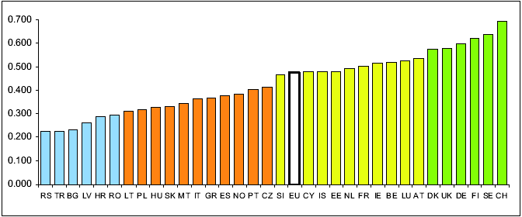



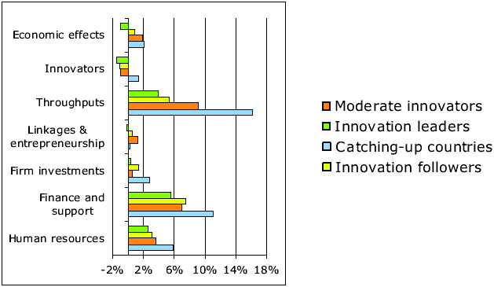

## 5.2 REGIONAL INNOVATION SCOREBOARD

|  |
| --- |
| The Regional Innovation Scoreboard (RIS) includes regional data for 16 of the 29 indicators used in the EIS. For the other EIS indicators regional data are not available. The definition of the indicators are identical to the EIS for 10 of these indicators, while for 6 indicators there is some difference. |
|
|



## 5.3 Innovation indicators for SMEs in Slovakia nad Hungary

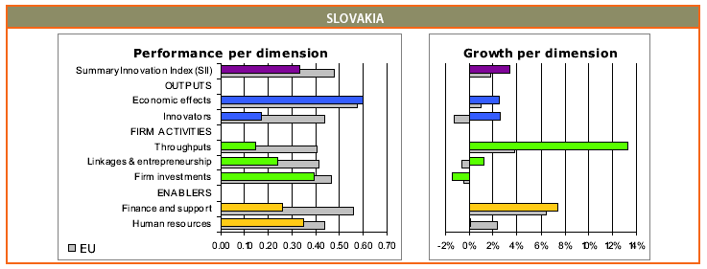

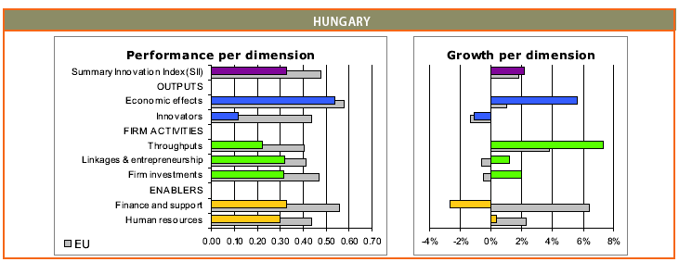

Previous work: Within the previous cooperation between the NTP and IQC, partners were searching, analyzing and comparing several training courses and methodologies to develop innovation skills in SMEs. The lecturers in SK and HU tried and studied the demo version of Innovation Suite v3.1. Consultation between NTP and CREAX about the technology and possible transfer forms of this tools and the CREAX methodology to SK an HU.

Needs analysis: On European Innovation Summit, in October 2009 partners met CREAX who delivered the presentation to the Summit. Since the summit CEAX, NTP, IQC gradually was developing the possibility to transfer the CREAX content to SK and HU. On innovation forum organized after European Innovation Summit by NTP were demonstrated the overall conceptions of innovation strategy for SMEs representatives. The result was to find a methodology, which had to be helpful with solution following problems: Missing innovation capital, Not enough developed innovation culture, low efficiency of production methods and the lack of SMEs productivity, Decreasing number of active SMEs in region

The most effective way to solve the urgent need is to realize and adapt the proven method learning content already successfully developed for SMEs.

**Main published indicators:**

1. SK and HU belong to group 4 - catching-up countries Source Innobarometer 2009 on DVD /EU/EU Innobarometer 2009

2. The GDP in Košice region is 44% of average in EU, Hungary 63,6 %. On DVD EU/ Regional GDP in the European Union.doc

3. Decreasing number of active SMEs in region - Year 2009, - 325 SMEs,

4 Low productivity, and low level of innovations in region. Year 2009 SK 75,9 %., HU 67,4 %. On DVD EU/ labour-productivity.htm or <http://epp.eurostat.ec.europa.eu/portal/page/portal/structural_indicators/indicators/short_list>

# 6. Aims and Objectives

The strategic aim of the project is raise the innovation awareness and skills of the SMEs in the regions of Hungary and in Slovakia.

The project will contribute to this aim by the targeting the following objectives:

- Transfer/customize of a proven Innovation suite learning service developed by CREAX to HU and SK language (Insuite-HU and Insuite-SK). The eLearning content will contain specifics for IT and for manufacturing sectors.

- To train pilot groups of trainers of the NTP and IQC training organizations.

- Dissemination of the InSuite-SK version to SK SMEs by NTP

- Dissemination of the InSuite-HU version to HU SMEs by IQC

- Involvement of further training organizations and sectorial consultants into the delivery and support of the Insuite learning service

The underlying success factor of the project is a practical learning on demand service accessible to SMEs in understanding and using the knowledge for their practical innovation project ( e. g. "show me latest patents for product category X manufactured by my company", "or for product Y new functions available, I want to manufacture")

The project primarily contributes to the priority LEO-TraInno-4 by facilitating SMEs ability in thes less developed regions to create, market & implement innovative products, services, processes and business models. The InSuite project is targeted at building new practice oriented knowledge, skills, competencies and capabilities that will enable the creation of a more agile workforce in both regions.

The project indirectly contributes also to LEO-TraInno-3 priority by training of VET trainers in this new domain of inovation related training and learning. We are with innovation education where we were with internet education ten years ago. Where internet as learning topic used to be more consumer oriented (learner as consumer of the internet), innovation requires learner self-motivation and engagement, and thus a prosumer approach (learner as active participant in the innovation process). This new engagement paradigm for learners will challenge the Consortium to transfer a high quality, attractive and engaging learning content and best practices of CREAX.

# 7. Type of Transfer

## 7.1 Sectoral transfer

Sectoral transfer: Transfer of Creax Innovation Suite "Part 1 IT sector" to Slovak and Hungarian IT sector SMEs.

### 7.1.1 Content description

A.1 eLearning module

This module is bringing practical tools and techniques for idea generation. These innovation skills increase the capacity to solve problems, to generate new product or process concepts and to find new markets for existing product. The training demonstrates how the company can use of worldwide knowledge through online knowledge sources to increase the company’s innovation skills.

A.2 Software tool for course "More inspiration" supporting the eLearning module, accessible from the learning portal

A.3 On-line test showing how creative are the IT managers and SW development employees

More: Innovation Suite Overview.pdf – on DVD directory CREAX enclosed

### 7.1.2 Method of transfer

1. NTP: buys the A.1 and A.2 licenses from CREAX with the rights to translate to Slovak and Hungarian languages

2. NTP, IQC: Translate the A.1 curriculum and the helps of More inspiration into Slovak and Hungarian languages

3. NTP, IQC: Adapting the course to local environment – examples, exercises /SK,HU/

4. CREAX: Training of 4 trainers of IQC(HU) and 4 trainers from NTP (SK) . Common training delivered in English

5. NTP, IQC: Adapting the curriculum and Innovation suite fir SMEs in IT sector

The training organizations will leverage their training offerings by a new innovative content not available yet for IT SMEs. 10 IT SMEs trained in each region within the workshops of project.

Sectoral transfer: Transfer of Creax Innovation Suite "Part 2 Manufacturing sector" to Slovak and Hungarian Manufacturing sector

1. NTP, IQC: Adapting the curriculum and Innovation suite for SMEs in manufacturing sector

Training organizations: P0 and P2 will substantially leverage their training offerings by a new innovative content not available yet in their regions for target group, Manufacturing SMEs. 10 Manufacturing SMEs trained in each region within the workshops of project. 300 SMEs registered to the InSuite learning platform in each Region one year after project completion

## 7.2 Geographical transfer

Geographical transfer: Transfer of CREAX Innovation Suite "Part 1 IT sector" and "Part 2 Manufacturing sector" to Košice region during the project duration. For long term activity NTP plan to cover SMEs in Slovak Republic. The marketing and dissemination activity of IQC cover the transfer of CREAX Innovation Suite for Hungary.

# 8. Base of the innovative content

1.CREAX methodology as is demonstrated on 2 days course "More inspiration" The curriculum and the training materials, as ppt slides, trainer manual, student workbook, examples, exercises of "More inspiration" course will be translated by NTP and IQC into Slovak and Hungarian languages and implement to the local social-cultural environment.

2. Transfer of software tools "CREAX Innovation Suite v3.1". Partners, NTP and IQC adapting the course to local environment with examples, exercises to SK and HU.

Rationale behind choosing the above result/s as basis for this proposal:

CREAX owns a successful methodology for the innovation skills training to make the innovation transfer more effective. Transferring this training content, CREAX methodology and know how to SK and HU. Transfer of this technology helps to SMEs companies from SK and HU to improve their level of innovation skills.

How does the proposal use the results:

The immediate result of the project is reduce the innovation learning gap in the SME Regions of Hungary and Slovakia by transferring a proven training curriculum.

The source of transfer is the Innovation Suite developed by CREAX (P1) already successfully delivering these training to SMEs in BeneLux. Primary beneficiaries are two training organizations: Novitech Partner(P0) and IQC(P2). Partners P0 and P2 will deliver InSuite learning services to the target beneficiaries - SMEs in Hungary and in Slovakia. Both are recognized training providers in their regions, and add the transferred curriculum to company training portfolio. The course "More inspiration" will be available for SMEs in region in SK and HU languages with local consultants and trainers support.

The current partnership was established with the initial developer and owner of the methodology know-how.

Enclosed DVD contain in directory CREAX:

1. Files related to CREAX methodology

More Inspiration Course Invitation 2010

Solution_Marketing.pdf

Problem_Solving.pdf

Innovation_Study.pdf

CREAX Creation Suite Folder & FBO Form

2. Files related to software tools "CREAX Innovation Suite v3.1"

Innovation Suite Overview.pdf

Demo version of Product : InnovationSuite3.1-eval(03-01-2005).exe

InnovationSuite3.1-UserManual.pdf

Web site: www.creax.be contain information about CREAX methodology in parts: Services, Software, Training.

# 9. Quality of the consortium

The consortium consists of tree partners. NTP is project coordinator and core partner, P1 and P2 are partners. Partner 1, CREAX is the owner of the methodology. In the innovation transfer he play a role of transferrer. The other two partners (P0,P2) are beneficiaries. The consortium possesses the skills and competencies required to ensure that the LLP work programme can be undertaken efficiently, effectively and professionally. CREAX has references in Europe for matters concerning innovation in SMEs. Their courses and software tools are based on own methodology, which is the subject of the innovation transfer in project InSuite. The implementation of e-learning content, the software support and the training of trainers should be in English language. Transferring the CREAX approach to SK and HU, make available a new competitive one methodology for SMEs in SK and HU. The consortium partners will be supported by CREAX innovation know-how specialist for preparing the curriculum, the training materials and the e-learning environment. CREAX as WP2 - (Dissemination and Exploitation Activities) - leader, transfer his best practices in field of dissemination to SK and HU partners. more: www.creax.be

P0 - NTP is Project manager and beneficent. The main function of NTP is to transfer a blended learning content form CREAX to SK. NTP currently have experiences with ECDL training and have strong background to implement and manage a new blended learning course based on CREAX methodology and curriculum. more: www.teledom.sk

IQC: Work package leader of WP3. The main aim of IQC activities is to improve the business performance of SMEs in region. The company have experience, knowledge and abilities, while success in business is only the effective mobilization of this resource base. IQC help systematize and apply knowledge, apart from IT means, through a new approach to organizational strategy. Knowledge Management serves as a basis for future success.

Currently supported activities:

* me-Learning™ (management e-Learning)

* Management Academies- Corporate University, On-line support – Virtual University

More on web site: www.iqc.hu

Organizations who declare the support of this project:

In SK: SOPK - Regional Chamber of Commerce and Industry, Košice, SK

Local government Košice, Department of Regional Development and Planning

Rergional Development Agency, Dolný Zemplín

In HU: Innovitas, Miskolc

The selected methodology is appropriate for achieving the objectives stated in the application.

Adequate and clear scheduling of activities to achieve the results proposed, including appropriate

outputs and milestones M1, M2 to allow project progress to be monitored.

The work programme and project organization ensure efficient, balanced and transparent co-operation

during the project work

# 10. European added value

The project provides a clear demonstration of visible benefits accruing from the collaboration of organisations across national borders including concrete opportunities for:

- Trans-national, interdisciplinary, trans-sectoral benefits;

- Transfer of knowledge and experience. for development of new learning content and methods

In more detail, the European added value of this transfer project will be created on several levels:

- Transferring a training service (good practice) form one developed region (Benelux) to other less developed regions of EU in the field of innovation training, where such a service does not exists yet.

- Transfer and sharing of training experience in the innovation domain between several EU training organizations

- Transfer and sharing of innovation cultures and attitudes among EU SMEs operating in different regions but in the same business sectors.

The project includes activities that will result in the conditions being met for the effective

Customisation of the transferred results. Linguistic and cultural issues will be appropriately addressed.

# 11. Methodology and workplans

The methodology of Work package managing is based on the standard Project management methodology. The project is divide to Work Packages (WP). Each WP contains some activities.

WP leaders:

NTP: WP1, WP4, WP5

CREAX: WP2

IQC: WP3

## 11.1 The work plan

WP or activity ID: Name of WP or activity Start date - End date

WP 1: Project and Financial Management 10/2010 - 09/2012

Activity WP 2.1: Project promotional tools and materials 10/2010 - 02/2011

Activity WP 2.2: Project promotional actions 03/2011 - 09/2012

Activity WP 3.1: Collection and analysis of materials and experiences 12/2010 - 01/2011

Activity WP 3.2: Identifying and analyzing targeted user requirements of product/service innovation skills development oriented 02/2011 - 03/2011

Activity WP 3.3: Selecting and analyzing innovative content, to meet these requirements and analysing the feasibility of transfer 04/2011 - 05/2011

Activity WP 3.4: Innovation skills development methodology guidelines for SME 05/2011 - 06/2011

Activity WP 3.5: Creation the quality handbook 07/2011 - 07/2011

Activity WP 3.6: Adapting Curriculum to the training systems of the Beneficiaries 08/2011 - 08/2011

Activity WP 3.7: Transferring the Curriculum to the new socio-cultural and linguistic contexts 09/2011 - 10/2011

Activity WP 4.1: Training of lecturers 10/2011 - 01/2012

Activity WP 4.2: Activities of facilitation/consultancy/assistance/follow up and feasibility plan for pilot actions 02/2011 - 04/2012

Activity WP 4.3: Training of target group 05/2012 - 09/2012

Activity WP 5.1: Valorization plan 01/2012 - 04/2012

Activity WP 5.2: Sustainable valorization management 05/2012 - 09/2012

## 11.2 Deliverables of the project



## 11.3 Support actions

Project Control 10/2010 09/2012

Media Communication 10/2010 09/2012

## 11.4 Translation and training activities time table

Preparation M1-M3

Translation SK M4-M6, M7-M9

Translation HU M4-M6, M7-M9

Internal test SK M7-M9, M10-M12

Internal test HU M7-M9, M10-M12

Beta test SK M13-M15, M15-M18

Beta test HU M13-M15, M15-M18

Training of trainers SK M10-M12

Training of trainers HU M10-M12

Training SK M15-M18, M19-M21

Training HU M15-M18, M19-M21

End user SK M19-M21, M22-M24

End user HU M19-M21, M22-M24

## 11. 5 Activity: Activity description

## 

Preparation: Preparation for translation. Dictionary. Translation of documentation.

Translation: SK Translation to Slovak language. 2 translators /1 internal + 1 external/. Duration up to 6 month

Translation: HU Translation to Slovak language. 2 translators /1 internal + 1 external/. Duration up to 6 month

Internal test SK: Testing inside company.

Internal test HU: Testing inside company.

Beta test SK: Testing outside company for functionality of program in local language

Beta test HU: Testing outside company for functionality of program in local language

Functionality of program in local language

Training of trainers SK: Training of trainers. May start earlier from M7.

Training of trainers HU: Training of trainers. May start earlier from M7.

Training SK: Courses and training for end users. 10 SME companies from SK. The training activities are between M15 -M21

Training HU: Courses and training for end users. 10 SME companies from HU.

End user SK: End users in house use of the product. Duration 3 month after finishing the course.

End user HU: End users in house use of the product. Duration 3 month after finishing the course.

# 12. Dissemination and exploitation of results

The dissemination strategy is based on two stages:

## 12.1 Dissemination during the project

- Two workshops organized in HU and SK demonstrating the practical use of the service to Target SME groups, to other training and advisory organizations not participating directly in the project.

- Periodic notification news of both training organizations with database of several hundreds of clients: These will be notified about the new service via the portals of NTP and IQC.

- Press conference

## 12.2 Dissemination after project completion

- Regular infodays about the use of the InSuite learning service in 3 month periodicity for both NTP and IQC existing training clients.

- Dissemination through the network of the National Chambers of Commerce.

- Special dissemination days for further training and innovation consulting bodies (including the Regional development)on participating in the InSuite support for SMEs

The success and extent of the exploitation of the Isuite service at SMEs shall be derived from the success factors of the source service (Innovation Suite) in BeneLux SMEs. The consortium will carefully study and adopt similar pedagogical and exploitation scenarios being applied by CREAX in the introduction of the service to the market.

The exploitation targets set by the consortium:

- after project completion (Year 0): 20 SMEs from IT and Manufacturing sector will use the Insuite learning portal and service

- after Year 1: 80 SMEs will be registered as active users in the Insuite service portal in each Country and additional 6 training and consulting bodies will join and support the Insuite learning service which shall be extended/customize gradually to further sectors.

-after Year 2: 300 SMEs will be registered as active users in the Insuite service portal in each Country (Sk and HU).

The consortium represents an efficient composition of capacities and competencies to manage and to implement the proposed project, in terms of:

- Professional capacity: both beneficiaries NTP and IQC has a skilled and experienced staff for introduction and for the delivery of new training services: lecturers, marketing, administration and technical support. Several instructors nominated to the transfer project were already participating in EU level innovation management trainings and tests ( e.g. IMPROVE training by AT Kearney in Dusseldorf) and also in past Leonardo projects.

- Financial capacity: NP and IQC posses the sufficient resources to cofinance the project and also after-project marketing and dissemination activities. About 43% of project budget, directly or indirectly is allocated to dissemination and to exploitation activities

-Technical infrastructure: to save hosting and infrastructure costs, both HU and SK versions of the InSuite portals will be hosted in the datacenter of NTP in Kosice , Slovakia.

# 13. Quality management plan

The Quality management shall plan, monitor and evaluate the following two aspects:

1- Quality of the project implementation process

2- Quality of the impact (innovation knowledge level before and 6 months after using the InoSuite learning service)

Quality of the project implementation process will follow:

- Quality responsibilities of all InSuite Project partners

- Proposed project quality management system.

- Document control of project documents, namely at milestones M1,M2 at the end of the project

- Inspection, acceptance testing and integration testing of InSuite learning service components

- Procedures for taking corrective actions

- Quality Audits. An external, project audit is be planned by milestones M1 and M2

Quality of the impact will be implemented by processing and evaluating an on-line survey results taken just after the first registration of the user into the InSuite portal and then 6 months later. These reviews will also contain user expectations and proposals for the improvement of the learning service.

The Quality plan will be monitored and evaluated by an independent external evaluator body with pedagogic and research experience in VET.

Staff resources for the above activities are allocated in Workpackage 1 (WP1).

# 14. Expected impact

## 14.1 Indicators for impact on target groups and/or sectors

The indicators for impact of the project are envisaged on two levels: (1) Training organizations as target group: P0 and P2 will substantially leverage their training offerings by a new innovative content not available yet in their regions. (2): target group, knowledge intensive IT and Manufacturing SMEs: 10 IT and 10 Manufacturing SMEs trained within the workshops of project. 300 SMEs registered to the InSuite learning platform in each Region one year after project completion

## 14.2 Indicators for impact on geographical areas

Training organizations: P0 and P2 will substantially leverage their training offerings by a new innovative content not available yet in their regions. for target group, knowledge intensive IT and Manufacturing SMEs: 10 IT and 10 Manufacturing SMEs trained in each region within the workshops of project. 300 SMEs registered to the InSuite learning platform in each country two years after project completion.

The project will contribute to aim of proposal by the targeting the following objectives:

- Support and customize of a proven Innovation suite learning service (Insuite-HU and Insuite-SK).

- Enhancing the eLearning content specifics for IT and for manufacturing sectors.

- Continue in training of trainers of the NTP and IQC

- Continue in dissemination of the InSuite-SK version to SK SMEs by NTP

- Continue in dissemination of the InSuite-HU version to HU SMEs by IQC

- Involvement of further training organizations and sectorial consultants into the delivery and support of the Insuite learning service

Training organizations P0 and P2 will substantially leverage their training offerings by a new innovative content based on CREAX methodology not available in this time in their regions.

The impact of the project is envisaged on two aspects: (1)Training organizations P0 and P2 will substantially leverage their training offerings a new innovative content by e-learning portal not available yet in the country. (2): The expexted impact for the target groups in Sk and HU, knowledge intensive IT and Manufacturing SMEs: 300 SMEs registered to the InSuite learning platform in each Region one year after project completion

CREAX - BE: Because the partners from SK and HU using the same testing and learning environment, CREAX can enrich his test result DB about innovation potential of SMES from SK and HU. Adapting the CREAX methodology in SK and HU create an opportunity to transfer to another countries in the same level of innovation culture and potential.

IQC HU: Have similar impact in Hu like NTP in SK.

# 15. Project budget

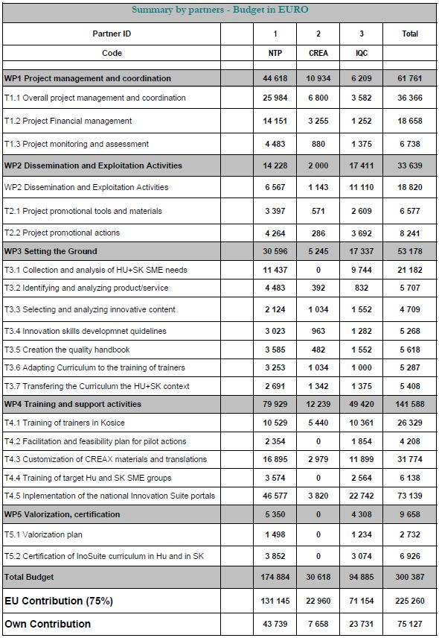

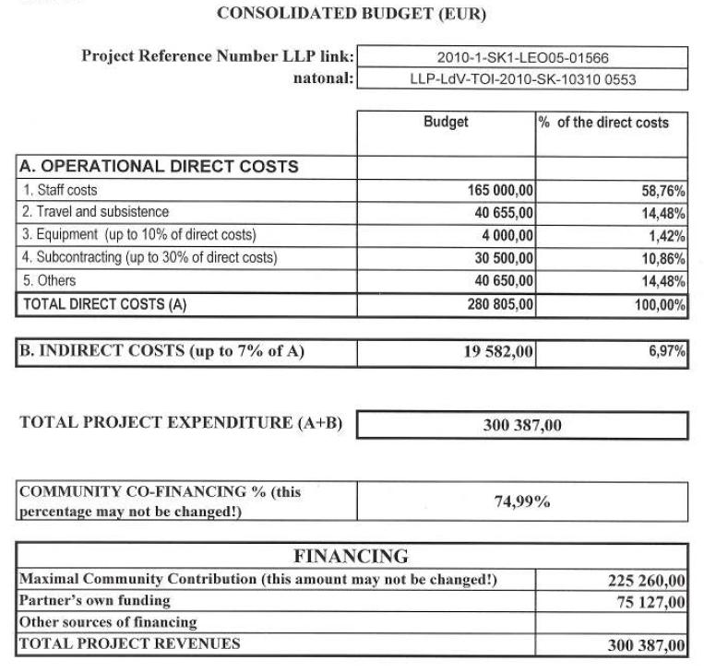

# 16. Conclusion

All participating companies acting as partners in the project "Curriculum Innovation Suite training for SME managers" - NTP (SK), IQC (HU) and CREAX (BE) create a stable partnership in the project, which is based on the existing cooperation in the field of innovative training proceses and presentations innovative training processes with a view to cooperation in the near future.

Each of the partners have many years experience in dissemination, education and communication in the area of the project, which is an important precondition for ensuring the implementation with expected results and outcomes to the systems and practices within the training of target group even after the end of the project.